Game Design Document

Fill up the following document

1. Write the title of your project.

Dodge the Car!

1. What is the goal of the game?

The goal of the game is to dodge as many car as possible.

1. Write a brief story of your game.

Sam, a mechanic is given the task to deliver his customer’s car. In his way he has to face too many car obstacles.

Can Sam be able to deliver his customer’s car to his destination!

1. Which are the playing characters of this game?

* Playing characters are the ones who respond to the user based on the input from the user.
* Cars, monkeys, dinos, wizards, etc., are the playing characters in the game.

|  |  |  |
| --- | --- | --- |
| Number | Character Name | What can this character do? |
| 1 | Sam | Can dodge the car obstacles |
| 2 |  |  |
| 3 |  |  |
| 4 |  |  |
| 5 |  |  |
| 6 |  |  |
| 7 |  |  |
| 8 |  |  |

1. Which are the Non-Playing Characters of this game?

* Non-Playing characters are the ones that don't have an action or behavior when the user interacts with the game.
* Hurdles, stones, bananas, coins, etc., are non-playing characters in the game.

|  |  |  |
| --- | --- | --- |
| Number | Character Name | What can this character do? |
| 1 | Truck | Is a obstacle |
| 2 | Car1 | Is a obstacle |
| 3 | Car2 | Is a obstacle |
| 4 | Ford | Is a obstacle |
| 5 | scooter | Is a obstacle |
| 6 |  |  |
| 7 |  |  |
| 8 |  |  |

Draw your imagination of this game. What does this game look like?

* Draw the game either on your computer or on paper.
* Add images of the game scenes to show each of the playing and non-playing characters at least once.

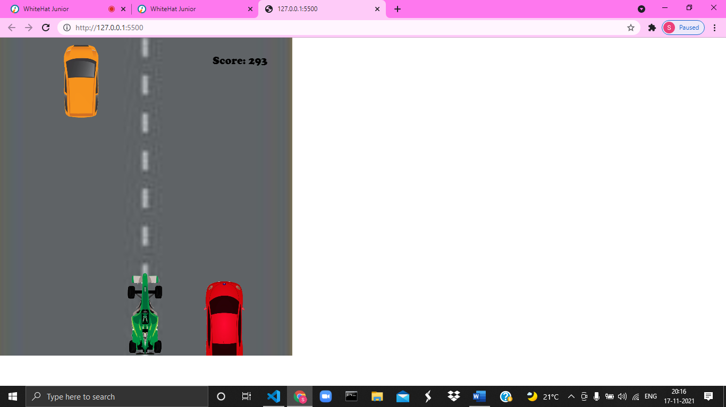

How do you plan to make your game engaging?

The more the score, the more the Speed, the more the difficult!